Type

>>> chmod u+x ./md.py

nohup ./md.py > t50k.pdb 2> output.err &

This will output 1001 frames of 500 atoms to the text file. Replace 50 with 300, 1000 to test the other T values.

To get the diffusion coefficients, type

>>> chmod u+x ./average.py

>>> ./average.py < t50K.pdb > t50K.out

This will print i, j, and the matrix element at (i, j), (i+1, j), (i+2, j) columns and rows.

>>> gnuplot

>>> plot “t50K.out” u 1:2 w l

Replace 50 with 300, 1000 for the other values.

The molecular dynamics of a Lennard-Jones gas such as Argon can be quantified by

Lennard-Jones eqn here

To calculate the diffusion coefficient, we plot the root mean square deviation (RMSD) of all the atoms in the system versus time. This will allow us to estimate the slope as time approaches infinity, where the diffusion coefficient D is approximately equal to 1/6th of the slope of the graph.

T = 50K:

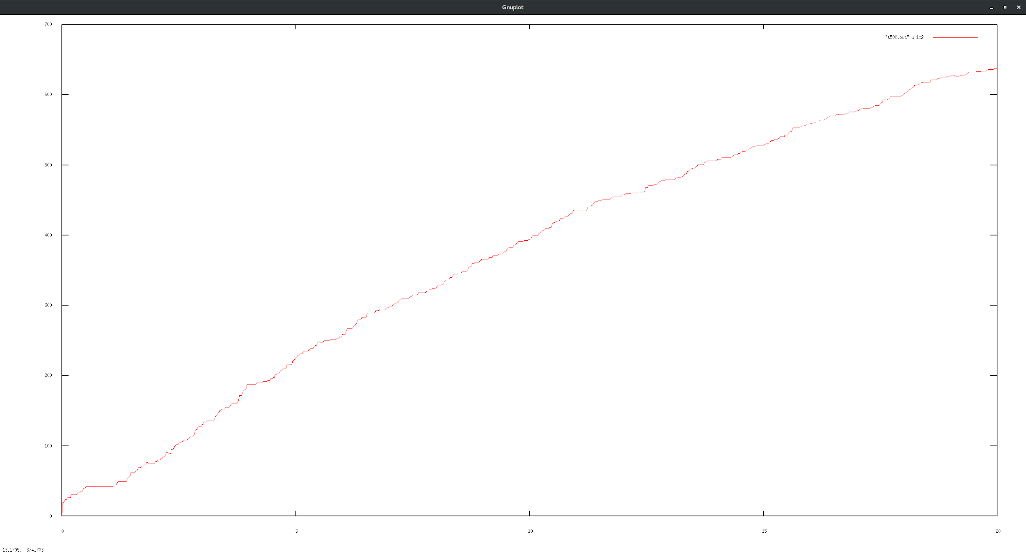

The diffusion coefficient value decreases at large t, but the trend is nearly linear.

T = 300K:

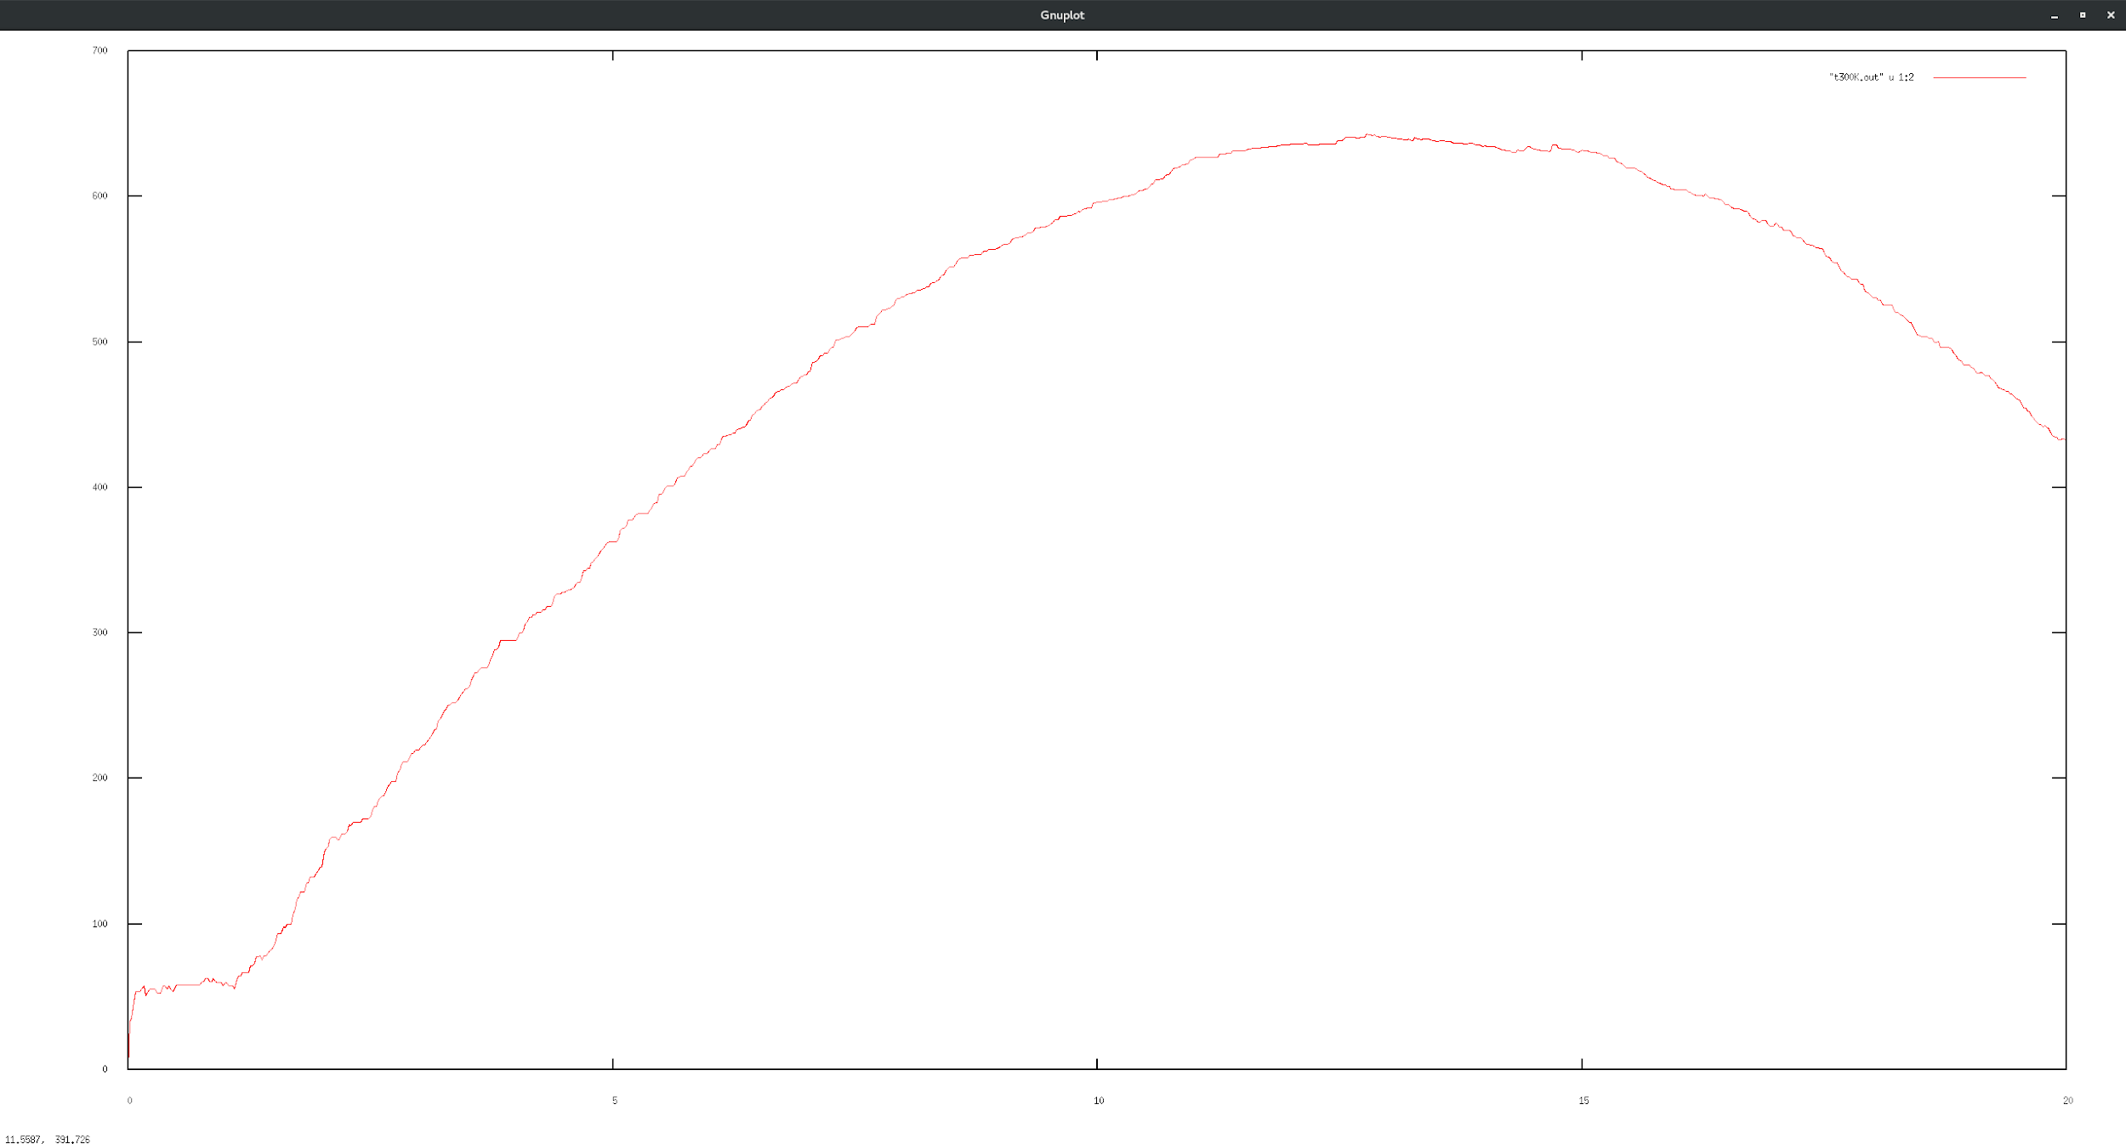

We can see that the diffusion coefficient is negative at high temperatures. At the local maxima (~t=12) the diffusion coefficient is zero.

T = 100K: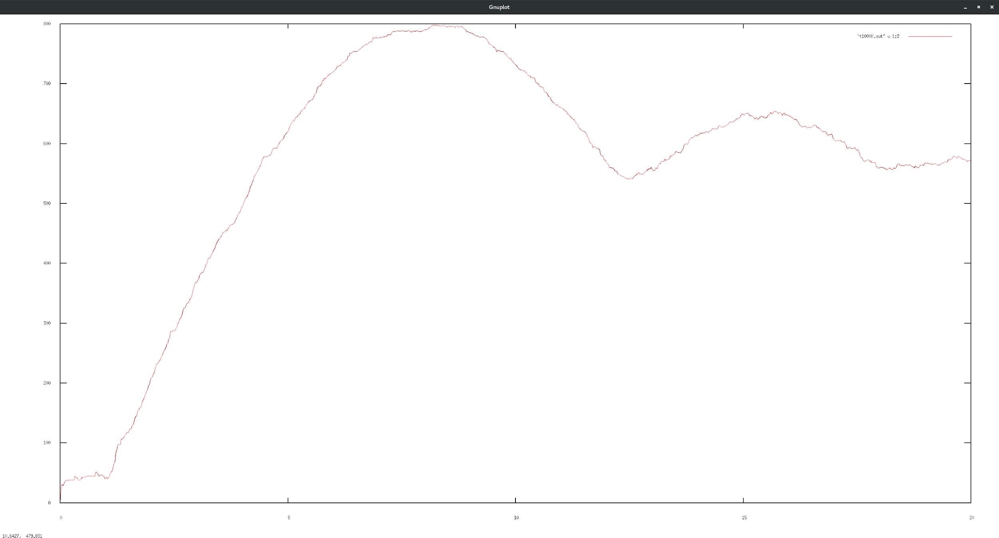

This graph has two local maxima at ~t=7 and ~t=16, but the diffusion coefficient as t->infinity is approximately zero at this temperature.